Alfredo Pinto Vieira de Melo
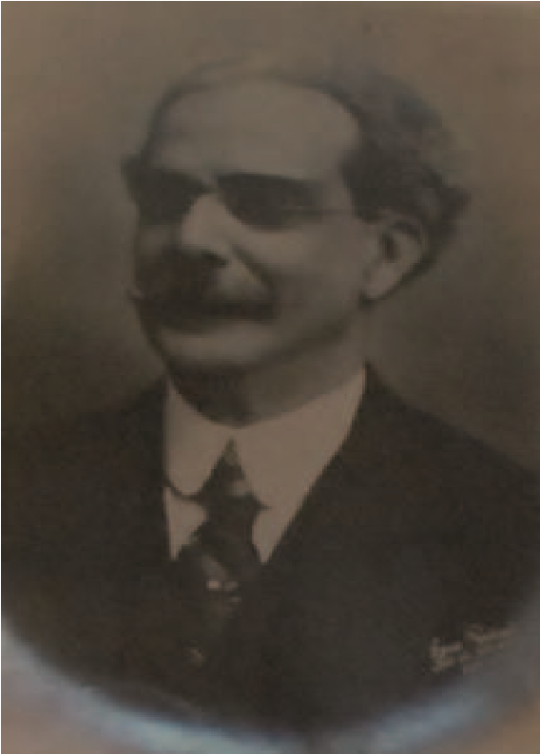
Alexandre Magalhães de Mattos

A

lfredo Pinto Vieira de Melo, better known as Alfredo Pinto, had Colonel João Vieira de Melo e Silva, political head of the city of Caruaru and Dona Maria Pinto Vieira de Melo, known as Dona Sinhá, as parents. (1)
Alfredo Pinto was born on June 20, 1863. Some of his biographies indicate that his birth city was Recife (PE) while others consider the city of Caruaru. The controversy is clarified in the work “The Prime Minister of the Country of Caruaru”, where it is reported that Alfredo Pinto was born in Rua da Frente (now XV de Novembro) and that he was baptized in the Igreja Matriz Nossa Senhora das Dores de Caruaru by Father Antônio Freire de Carvalho, known by the nickname Vigarinho. (1)
Alfredo Pinto passed away at the age of 60 on July 8, 1923 in the Federal District, the current city of Rio de Janeiro, having been buried in the São João Batista Cemetery, in the Botafogo neighborhood. (two)
Alfredo Pinto spent his childhood and part of his adolescence in Caruaru, where he studied with Professor Ana Joaquina Peres Campelo de Oliveira Melo. At the end of his studies he moved to Recife, where he joined the Faculty of Law of Recife, graduating in Legal and Social Sciences in 1886. (1, 3)
Alfredo Pinto's professional and political life is very vast and we discovered some truncated information from the beginning of his professional life.
According to BARBALHO, in the same year of his graduation, Alfredo Pinto traveled to Minas Gerais, where he took charge of the Public Prosecutor but, in LAGO studies, before that trip to Minas Gerais, Alfredo Pinto was appointed Municipal Judge of Orphans of the term de Palmeira in the province of Rio Grande do Sul according to Decree of 21 October 1887. No study is given that he did not accept such an appointment and this became void, being annulled by the Decree of 5 November 1888.
Both BARBALHO and LAGO agree that his trip to Minas Gerais was due to the fact that he assumed the position of Public Prosecutor. This position was held in the Baependi District until he was appointed to the position of Judge of Law of the District of Ouro Fino through the Decree on December 27, 1890.
After a 3-year career in the judiciary, Alfredo Pinto was invited to exercise the charge of the Chief of Police of the State of Minas Gerais under the Afonso Pena and Bias Fortes governments, from 1893 to July 16, 1896, when he asked to be removed from office.
After this phase, Alfredo Pinto began his political career, being elected state deputy until he was elected in 1897 as a Deputy to the National Congress (Federal Deputy) when he moved to Rio de Janeiro, the then capital of the country. In 1900 he was elected to the same position. (4)
In 1903 Alfredo Pinto abandoned politics and began to practice law in the Federal Capital, being appointed representative of the National Treasury to the Works Committee of the Port of Rio de Janeiro by President Rodrigues Alves (1902-1906).
On November 15, 1906, Alfredo Pinto was invited by the then President-elect Afonso Pena, of whom he was a friend since he held the position of Chief of Police of the State of Minas Gerais, to assist the President in his government since he had participated in the campaign to presidency of the Republic. Accepting the invitation, he was appointed Chief of Police of the Capital of the Republic, the charge he left on June 16, 1909, at the end of Afonso Pena's government.
From then on Alfredo Pinto started to practice law and, between the years 1912 to 1914, he was elected president of the IAB (Brazilian Lawyers Institute), where he exercised the entity's 15th legislature. (5)
In 1917 Alfredo Pinto entitled the title of Doctor of Law and was appointed professor at the Faculty of Legal and Social Sciences in Rio de Janeiro, thus exercising, in addition to law, teaching law. (2-4)
Invited by President Epitácio Pessoa, he was appointed Minister of Justice and Business in his government, from July 28, 1919 to September 3, 1921. Still during the administration of Epitácio Pessoa, he was appointed interim Minister of War, a position he held on 28 July 1919 to October 3, 1919.
In 1921, already considered a notable jurist and with relevant services rendered to the public administration, on August 23, 1921 he was appointed Minister of the Supreme Federal Court (STF) by the Decree of President Epitácio Pessoa, filling the vacancy that arose with the death of Pedro Lessa . His inauguration took place on September 21, 1921, exercising it concomitantly with teaching until his death on July 8, 1923. (3, 4)
There were several important facts that marked Alfredo Pinto's life and career. As a law student in Recife, he stood out in the fight against slavery and was in favor of the Republic, being one of the supporters of Clube do Cupim, which brought together the main abolitionists in Pernambuco. Considered an agitator, he took refuge in the home of relatives in Timbaúba-PE, founding an avant-garde newspaper in that city. (1)
When he arrived in Minas Gerais, he founded the newspaper “Gazet
that of Ouro Preto ”. (1)
As the chief of police of the Federal District, during the Afonso Pena government (1906-1909), he was tasked with remodeling the organization, giving it a new and advanced stamp for the time. He also founded the Correctional Colony of Dois Rios, on Ilha Grande and the Identification Service of the Federal Capital, considered then one of the most important registration institutions whose function was to provide information about individuals with a criminal record. (4)
When he was elected as a federal deputy, he was elected President of the Federal Chamber's Legislation and Justice Commission and was chosen to be part of the “Commission of the 21”, a commission charged with drafting the Civil Code that would be enacted in 1916. (1)
He was also chairman of the Constitution and Justice Commission and a special member of the committee headed by Clóvis Bevilácqua, also acting as rapporteur for the first part of Book IV, "On the Law and Successions" of the Civil Code. (1-4)
As a federal deputy he also drew up the project to create the identity card. (3)
As a lawyer and member of the IAB, he participated in the commission of lawyers in charge of preparing a draft Code of Civil, Commercial and Criminal Procedure for the Federal District. (5)
In 1914 he participated in the 1st National History Congress, organized by the Brazilian Historical and Geographic Institute (IHGB), presented the remarkable thesis entitled “The Judiciary in Brazil (1532-1871). (2, 4)
In the position of Minister of Justice, Alfredo Pinto, he rendered relevant services to the nation, having achieved complete success in the Interstate Conference on Limits, of his initiative, which managed to settle the border demarcation conflicts between various States of the Republic. (two)
On December 22, 1920 Alfredo Pinto signed the decree that regulated the functioning of the female section of the Professional School of Nurses and Nurses of Assistance to the Alienated in the Federal District. The ordinance came into force as of its publication in the Official Gazette of September 21, 1921 and, in honor of Alfredo Pinto, the female section was named as Professional School of Nurses Alfredo Pinto. Currently the institution is called Alfredo Pinto Nursing School. (6)
Alfredo Pinto wrote important books and legal works. Considered a vibrant speaker, memorialist and historian, he also wrote poetry, short stories, novels, plays. (1)
Due to his intelligence and moral integrity, a special entry was given to “Dr. Alfredo Pinto Vieira de Melo ”in Volume I of the Brazilian Bio-Bibliographic Dictionary, edited by the National Library on July 8, 1923. (1)
Among the various works that he published in several specialized law magazines, "Scientific education", "The jury" and "Rights of successions" stand out. (4)
Honoring the memory of Alfredo Pinto, the mayor of the Federal District, through Decree No. 1,903, of October 2, 1923, gave the name “Afredo Pinto” to the stretch of the old Rua Club Atlético, between Conde de Bonfim and Pereira Barreto streets , at the site of the projected Avenida Maracanã. (two)

REFERENCES

(1) BARBALHO, Valéria. The Prime Minister of the Country of Caruaru. Diário de Pernambuco Impresso, Recife, January 29. 2015. Opinion section. Available at: <http://www.impresso.diariodepernambuco.com.br/noticia/cadernos/opiniao/2015/01/o-primeiro-ministro-do-pais-de-caruaru.html>. Accessed on: 29 mar. 2021.
(2) SUPREME FEDERAL COURT (Brazil). Ministers. Available at: <http://www.stf.jus.br/portal/ministro/verMinistro.asp?periodo=stf&id=197>. Accessed on: 28 mar. 2021.
(3) WIKIPEDIA (USA). Available at: <https://pt.wikipedia.org/wiki/Alfredo_Pinto_Vieira_de_Melo>. Accessed on: 28 mar. 2021.
LAKE, Laurenio. Supreme Court of Justice and Federal Supreme Court: biographical data 1828-2001. 3. ed. Brasília: Federal Supreme Court, 2001. p. 265-266.
(4) GUIMARÃES, L. First (v. 9); MATTOSO, P. Supreme Court; MELLO FILHO, J. Notes; SUP. TRIB. EDF. Available at: <http://www.stf.jus.br/portal/ministros>. Accessed on: 28 mar. 2021.
(5) INSTITUTO DOS ADVOGADOS DO BRASIL. Presidents gallery. Available at: <https://iabnacional.org.br/institucional/galeria-de-presidentes>. Accessed on 26 March. 2021.
(6) EEAP-NURSING SCHOOL. History of EEAP. Available at: <http://www.unirio.br/enfermagem/historia-da-eeap/historia-da-eeap>. Accessed on 26 March. 2021.

1 Lawyer, Systems Analyst, Master from the Federal University of the State of Rio de Janeiro (UNIRIO), PhD student at UNIRIO, Member of IAB (Brazilian Lawyers Institute at the International Law Commission and Digital Law Commission), Member of OAB / RJ in the Information Technology and Innovation Law Commission. E-mail: alexandre.m.mattos@bol.com.br. Tels .: (21) 2263-9586 / 99656-7831. ORCID 0000-0002-9331-9138.

